**Mini URL Services**

1. Environment Setup
2. Importing the code
3. Building the code
4. Testing
5. Docker
6. **Environment Setup**

Softwares needed

OS : Windows 7 or Higher/Linux/Mac OS

Editor : Eclipse (preferred), Net Beans etc

Tools : ORACLE JAVA 8 or Open JDK, MySql 8

1. **Importing the code .**

Unzip the MIniURLServices.zip into a folder of your choice. Use the import wizard in the IDE to get the code . Use a Maven Project to import.

1. **Building the code :** Use the Maven build, Ex: in Eclipse go to project (right click) select Maven and update the maven , to save time set Build automatically .
2. **Testing**

Application can be run as simple java application , the default port it uses is 4567

Use in the browser : <http://localhost:4567/hello>

The must return ; Hello - MiniURL microServices is up!!!

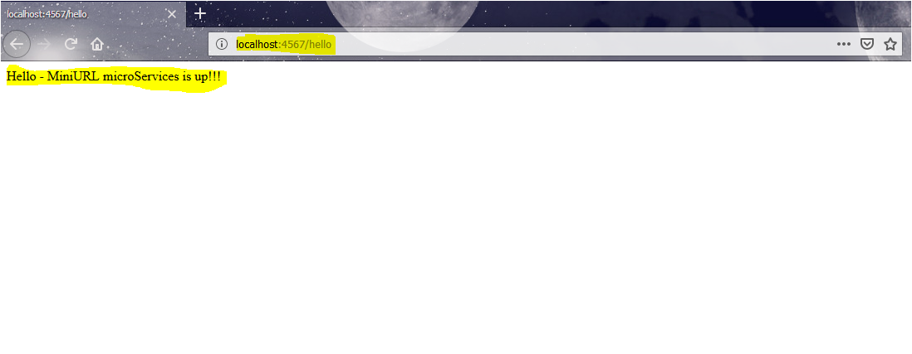

**Code Explained:**

**Main.java . Has all the get and post methods**

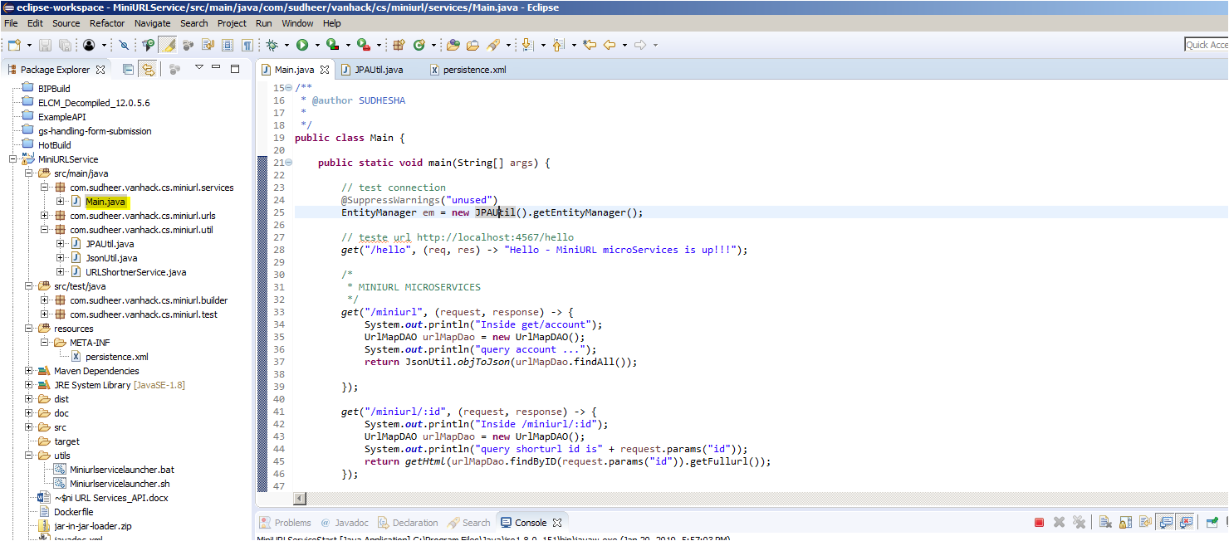

UrlMap.java has ORM

UrlMapDAO is data access object have methods to save and retrive

UrlMapService provides method to convert json to object.

JPAUtil is the JPA persistence manager, gets conf from persistence.xml

JsonUtil is for processing json

URLShortnerService this the class that will shorten the URL. It applies standard JAVA string compression .

getShortURL takes full URL and returns the short URL

Persistence XML has the persistence configuration:

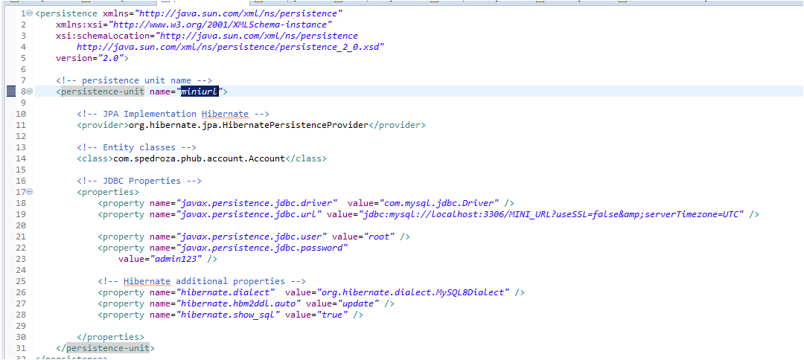

**Basictests.java has some basic tests**

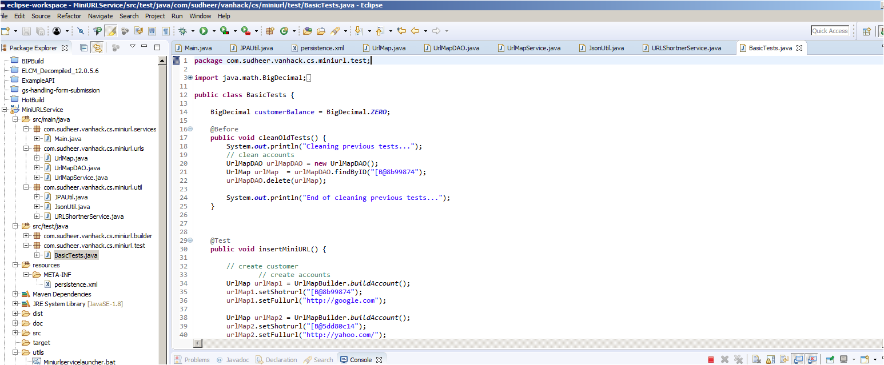

**Docker: Configuration is available under Dockerfile**

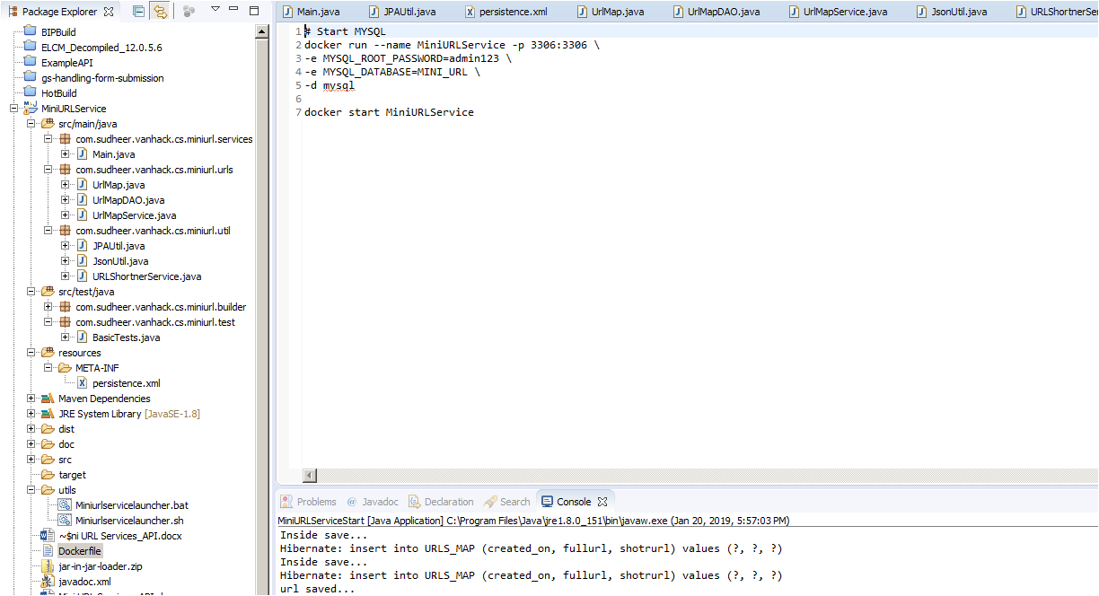

**To Run from Eclipse directly , use**

